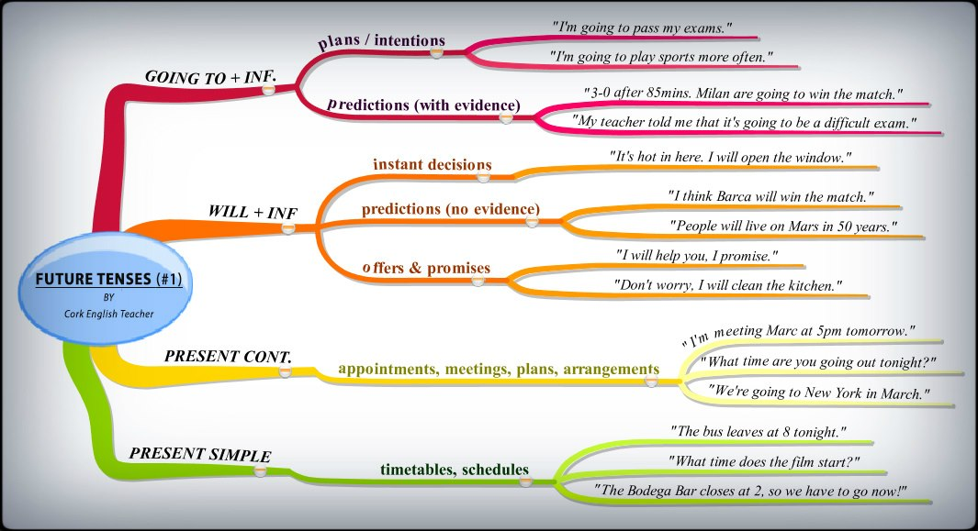
https://www.youtube.com/watch?v=0gyI6ykDwds

