**March, 17th: Saint Patrick’s Day**

1. **The Story:**

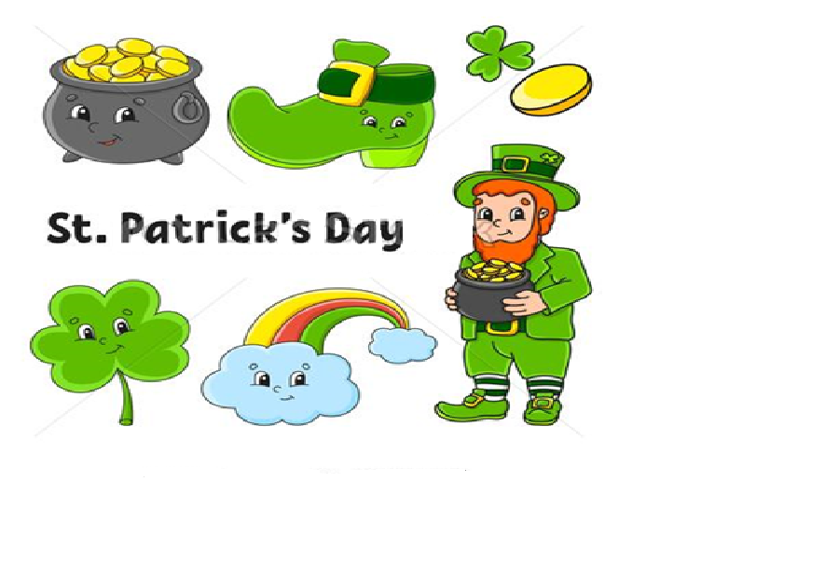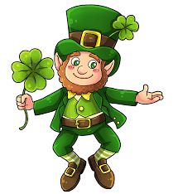[**https://www.youtube.com/watch?v=rwSGBzeg0pM**](https://www.youtube.com/watch?v=rwSGBzeg0pM)

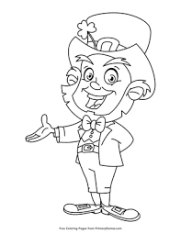

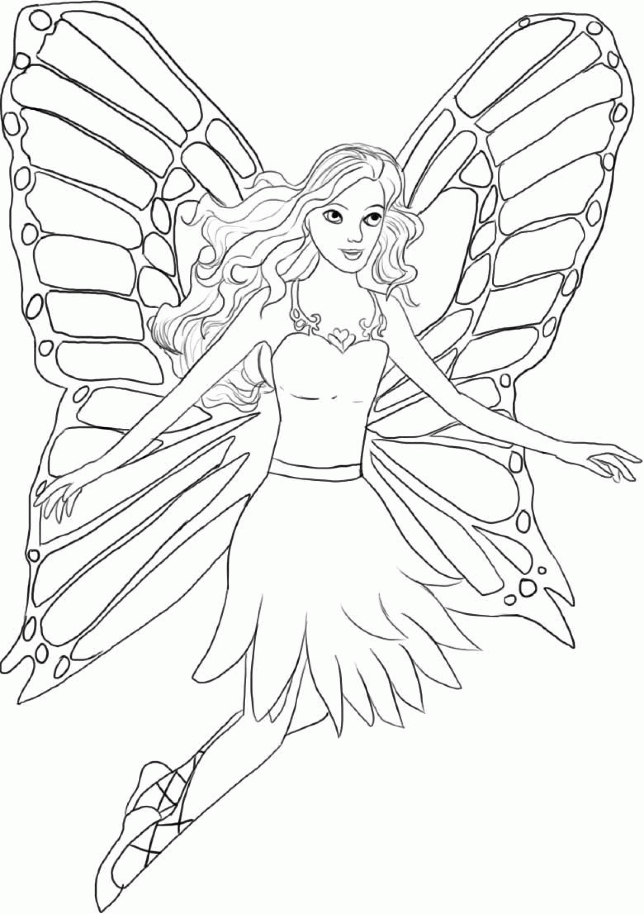**“Hi, I’m a Leprechaun. I make shoes for the fairies, I’m a shoe-maker”**

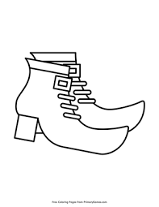

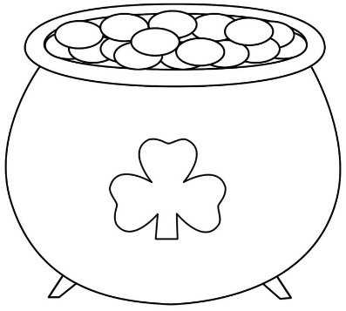**“Wow! Beautiful shoes! Here’s a golden coin for you.”**

**“Thank you, I have a pot of golden coins!”**

**“I want the gold! If you catch a**

**Where is it?”. Leprechaun and look**

**at him in the eyes, he must tell you the truth.**

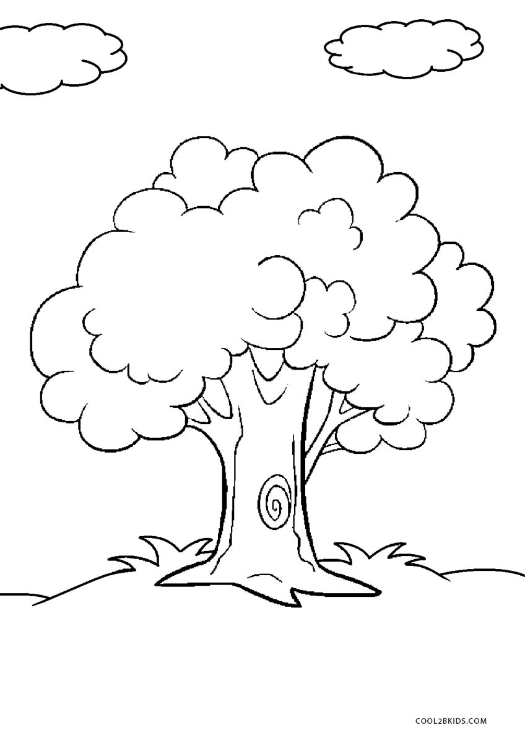

**“It’s under this tree”**

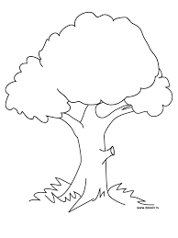



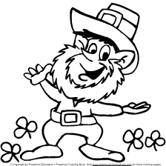



**“Oh! I need a spade … I’ll go home and take a spade, don’t take away the red ribbon!”**







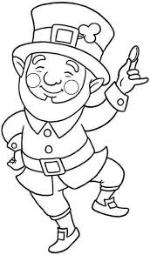

**“Oh! All trees have a red ribbon!”**

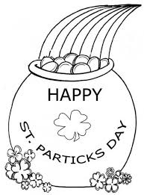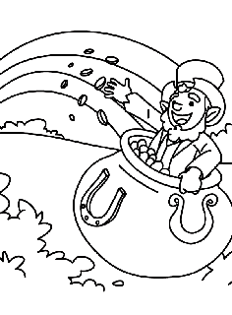 **“Ah, Ah, Ah!**

**My gold is safe, now!”**

1. **More Leprechauns to colour:**

