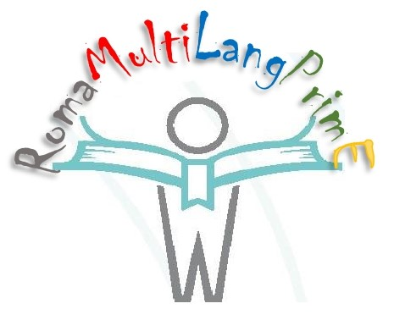 | Supporting Roma Children Integration via Multiliteracies and Multimodality for Language Learning in Early Primary Education (RomaMultiLangPrimE )» 2020-1-RO01-KA201-080342  Training course – 04 – 09/10.2021 Verona - Italy
Training course agenda

Time | Sunday  03/10/21 | Monday 04/10/21 | Tuesday 05/10/21 | Wednesday 06/10/21 | Thursday 07/10/21 | Friday 08/10/21 | Saturday 09/10/21
9.00 – 10.30 | Arrival | Ice breaking – among Participants  Presentation of the project (Coordinator)  Presentation of the agenda  (PEC) | “On site learning experience”  “Living stories”  with  Roma participants | Toolkit:  How to stimulate emotional engagement  How to stimulate a discussion on topics based on the story created by the children - Presentation of a narrative scenario | They will create stories for:  Rewrite parts of books using different multimedia - - Presentation of an argumentative scenario | “What have I learned?  Sharing of experiences and contributions - Presentation of an argumentative scenario | Departure
10.30 – 11.00 |  | Coffe break |  | Coffe break | Coffe break | Coffe break
11.00 – 12.30 |  | Toolkit:  How to create a story  How to find and integrate resources - Presentation of a narrative scenario |  | How to get children involved – call for action - Creation of a narrative scenario | They will create stories for:  Build new stories based on national stories or myths - Creation of an argumentative scenario | Continuing Discussions –  - Creation and evaluation of an argumentative scenario
12.30 – 12.45 |  | Questions and Answers |  | Questions and Answers | Questions and Answers
13.00 – 15.00 |  | Lunch | Lunch | Lunch | Lunch | Lunch
15.00 – 17.30 |  | How to find the best tools to convey the meaning  How to stimulate the 4Cs (Creativity, Communication, Collaboration and Critical Thinking) in children - Creation and evaluation of a narrative scenario | 15.00 Discussion about the experience  16.30 meeting with the schoolteachers 100 about - explaining the main structure of the project, and results | They will create stories for:  Basic narrative, argumentative and screenplays structures based on real and imaginary events and worlds for each participating country - Evaluation of a narrative scenario | They will create stories for:  Work on film and create their own mini movies with selfie show  Create basic structures for thought experiments for reasoning and argumentation in physics” - Evaluation of an argumentative scenario | What do I share? What next?”
17.30 – 18.00 |  | Conclusions | Conclusions | Conclusions | Conclusions | Certificate award/Europass award
20.00 | Dinner together  meeting lobby hotel | Dinner together  meeting lobby hotel | Dinner together  meeting lobby hotel | Dinner together  meeting lobby hotel | Dinner together  meeting lobby hotel | Dinner together  meeting lobby hotel

