How to reach Stra-TG Multiplier event

Università degli Studi di Verona

Polo Didattico “ Giorgio Zanotto”
Viale dell’Università 5 – Verona

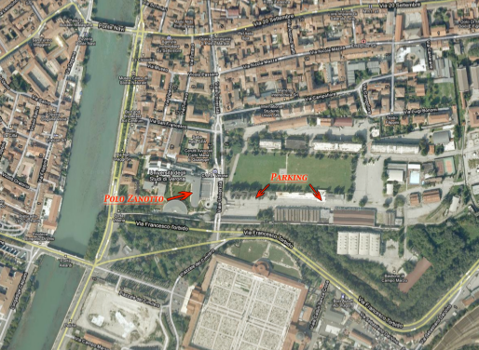

From Verona Porta Nuova Train Station

Bus, 11,12, 13, 51 Platform A . Go out to the first stop in Via San Paolo (corner Church of San Paolo ), Continue by foot in via dell'Artigliere to the end of the street, there You will cross the University alley, on the right you can find the Polo Zanotto.

From Verona Airport “Valerio Catullo”

Taxi or a but to the train station Verona Porta Nuova. When you are in train Station Porta Nuova follow the instructions to take the bus, or if you are in a taxi ask for Polo Zanotto Adress.

Parking: the parking "Passalacqua", is open from 7 a.m. to 20 p.m. it is in via dell'Università at about 100 Meters to Polo Zanotto.

